RDCJ-DY Series Impulse Voltage Generator

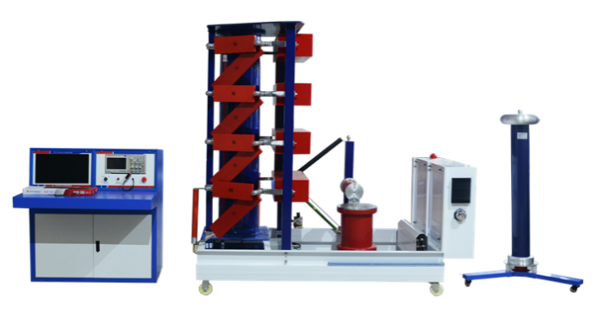
RDCJ-DY series impulse voltage generator is used for impulse voltage test of lightning impulse voltage full wave , lightning impulse voltage chopped wave and operation impulse voltage wave which apply to electrical equipment ect. Multiple waveform impulse voltage generator can produce eight kinds of waveforms of standard lightning wave, operation wave, lightning chopped wave, oscillating lightning wave, oscillating operation wave, line insulator steep wave, composite insulator steep wave, transformer induction operation wave. The technology index accords with national standard and IEC standard, is in the leading position at home and has reached an advanced level in the world
- Product Features
1. Complete sets, full voltage classes.
2. Small loop inductance, take the band elimination filter measures, still produce standard impulse wave in the large-capacity load, large load capacity, high voltage utilization, convenient to adjust wave.
3. Simple operation, excellent synchronization performance, reliable action.
4. Constant current charging technology, high automation, strong anti-interference performance.
5. Digital measurement and analysis system and computer on line processing system for impulse test data, greatly improve the test technology and efficiency.
- Product Specifications and Technical Parameters
Standard Voltage | Impulse Capacitance(µF) |  | Classes Capacitance(µF) |  | Impulse Energy(kJ) | Classes Voltage(kV) | Class |  | Weight(kg)
±300~±900 | 0.133~0.111 |  | 0.4~1 |  | 6~45 | ±100 | 3~9 |  | 547~1378
±1000~±1600 | 0.05~0.0937 |  | 0.5~1.5 |  | 25~120 | ±100 | 10~16 |  | 1366~1880
±1800~±2400 | 0.056~0.0833 |  | 0.5~1 |  | 90~240 | ±200 | 9~12 |  | 7353~11574
±2800~±3200 | 0.0357~0.0625 |  | 0.5~1.5 |  | 140~320 | ±200 | 14~16 |  | 10266~15680
±3600~±4800 | 0.0278~0.03125 |  | 0.5~2 |  | 80~240 | ±200 | 18~24 |  | 15480~23500
Technique Parameters
Items |  |  |  | 1,1.2/50µs 2,250/2500µs 3,2~5µs etc waveforms
Output Peak Value |  |  |  | 100~10000kV
T1 Wave Front Time |  |  |  | 1.2µs±30%
T2 Wave Tail Time |  |  |  | 50µs±20%
Reverse Overshoot |  |  |  | <20%
Voltage Polarity |  |  |  | Positive/negative(manual shifting)
Waveform Shift |  |  |  | Auto shifting
Charging Time |  |  |  | 10s~999s, set arbitrarily
Instability of charging voltage |  |  |  | <1%
External Input |  |  |  | 50Hz/60Hz
Trigger Method |  |  |  | Auto or manual, can single trigger
Trigger Maloperation rate |  |  |  | <1%
Trigger Range |  |  |  | 100% rated charging voltage
Display Screen |  |  |  | 17-inch TFT color screen
Measurement Display Precision |  |  |  | Better than 3%
Tested Product Residual Voltage |  |  |  | <5kV
Voltage Measurement |  |  |  | Use damped impulse divider
Oscilloscope |  |  |  | TBS series, optional
Insulation Strength |  |  |  | ≤500V RMS (common to ground refer PE)
General Parameters
Power Source |  |  |  | AC220V±10%, 50/60Hz
Environment Temperature |  |  |  | -10±40ºC
Relative Humidity |  |  |  | 35%-85% RH (no condensation)
Ground Resistance |  |  |  | ≤0.5Ω
Structure Type |  |  |  | Open structure, independent control cabinet and main body, optical fiber connection
Control Console |  |  |  | 1.8M(length)*1.2M(height)*1M(width)
No conductive dust, no fire and explosion hazards, no corrosive metal and insulation gas, waveform
of power voltage is sine wave, distortion <5%.
Equipment model selection parameters
Nominal Total Voltage kV |  | Class | Impulse Capacitance (μF) |  | Impulse Level Capacitance(μF) | Total Charging Power(kJ) |  | Application
±300~±900 |  | 3~9 | 0.133~0.111 |  | 0.4~1 | 6~45 |  | 35~110kV
±1000~±1600 |  | 10~16 | 0.05~0.0937 |  | 0.5~1.5 | 25~120 |  | <220kV
±1800~±2400 |  | 9~12 | 0.056~0.0833 |  | 0.5~1 | 90~240 |  | 220kV~500kV
±2800~±3200 |  | 14~16 | 0.0357~0.0625 |  | 0.5~1.5 | 140~320
±3600~±4800 |  | 18~24 | 0.0278~0.03125 |  | 0.5~2 | 80~240
Minimum time difference between pulse |  |  | 30s |  |  | 40s
Generator capacity per level |  |  | ≤1600kV use 100kV single side charging 1 |  |  | ≥1600kV use 100kV double sides charging

